ACCS Training Programme
Clinical Supervisor Meeting Record

Type of meeting: Initial / Midpoint / End of placement
Date of meeting:
Meeting via:
Trainee name:
Parent Specialty:
Current placement:
LTFT % / Full Time Training
Educational Supervisor (parent speciality)
Name: Job Title:
Clinical supervisor (if different)
Name: Job Title:

Current Placement
-Department……………. Site…………………….
-Placement start date …………………
-Placement end date …………………..
Induction attended? Y / N
Registered with Parent specialty Royal College?: Y / N
Trainee & Supervisor able to access e-portfolio?: Y / N
Understand how to use eportfolio for ACCS Programme? Y / N
(Training provided by: A trainee/ Supervisor/ College Tutor/ ACCS Site Lead/ LLP Lead (Matthew Williams)/ TPD/ attended all Wales induction training/ other)
Aware of resources for ACCS Training information?
- ICACCST https://www.accs.ac.uk/
- AWSEM www.awsem.co.uk/accs 3)
- RCOA www.rcoa.ac.uk
- WSOA www.welshschool.co.uk
- RCEM www.rcem.ac.uk
- JRCPTB www.jrcptb.org.uk
- FICM www.ficm.ac.uk

CURRICULUM
For each applicable ACCS Curriculum Learning Outcome (LO) in this placement detail any:
- Objectives, agreed with the trainee and as set out in PDP
- Evidence which will be used to ensure these objectives are met
- Progress made so far

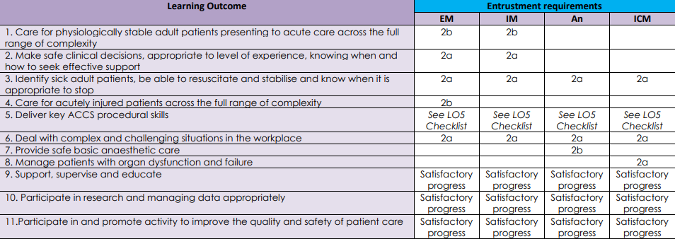
LO1:
LO2:
LO3:
LO4:
LO5:

Procedure | Entrustment level by end of first 2 years of ACCS
Pleural aspiration of air/fluid | 2a
Seldinger chest drain | 2a
Open chest drain | 1
Establish invasive monitoring (CVP and art line) | 2a
Vascular access in emergency (IO and femoral vein) | 1
Fracture dislocation/manipulation | 1
External pacing | 2a
Direct current cardioversion | 2a
Point of care guided vascular access and fascia iliaca block | 2a
Lumbar puncture | 2a
Sedation | 2a

LO6:
LO7:
EPA1 /EPA2 / IAC

Local/ Regional resources and opportunities available to trainee highlighted?
Generic competencies
-LO9:
-LO10:
-LO11:

STUDY LEAVE AND EDUCTIONAL DEVELOPMENT
ACCS training days

Cardiology |  | Trauma
Respiratory |  | Critical care
Sepsis |  | Management
Skills day |  | Diagnostics

EDT
Has EDT been formerly rota’d? Y/N
What are the arrangements for EDT? In hospital/ Out of hospital / Mixed
What are the Trainee’s objectives for EDT in this placement?

WELLBEING AND SUPPORT
Are there any specific induction considerations to be discussed?
General considerations eg Distance travelled on commute /support network/ accommodation
Aware of available hospital rest facilities ? Y / N
Aware of available departmental support? Y / N
Aware of Professional Support Unit? Y / N

SUMMARY
Any training concerns at this stage? Y / N
Most current ARCP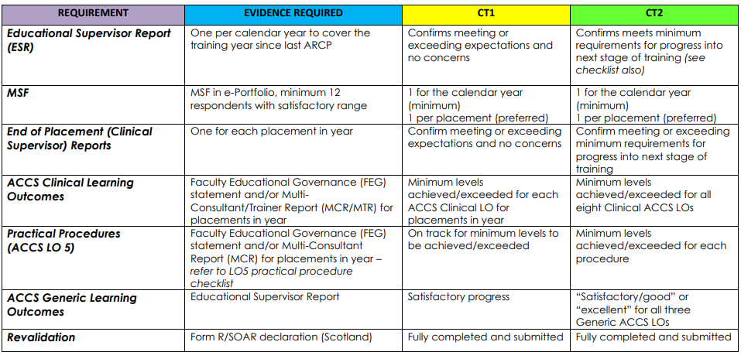 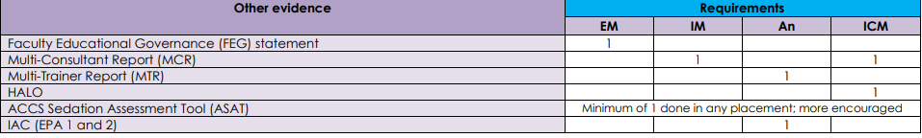Requirements for the training year discussed? Y / N

Date agreed for next meeting:
Trainee to upload this record of the Supervisory meeting to LLP as a Personal Activity, under Supervisory Meeting.
ES Signature…………………………………………………….. Date …
Trainee Signature……………………………………………… Date …

